Mars Weather
Data Analytics Boot Camp
Project 2
Dale Ohmart

The Mars Curiosity Rover landed successfully on Mars on August 5, 2012 near the foot of a mountain in Gale Crater.
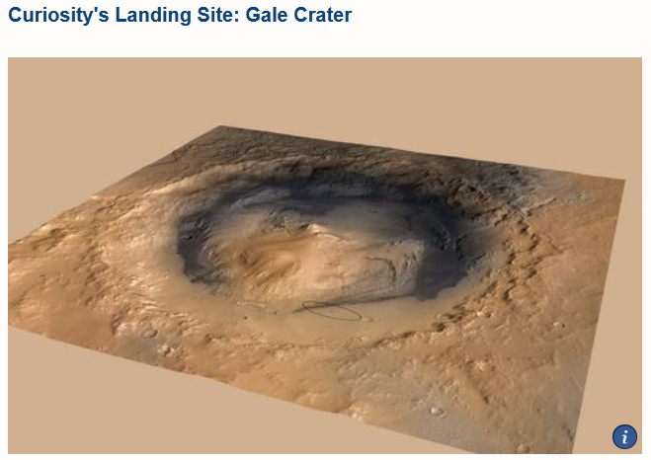
The landing location was 4.5 degrees south latitude, 137.4 degrees east longitude. Curiosity is therefore slightly south of the Mars equator.
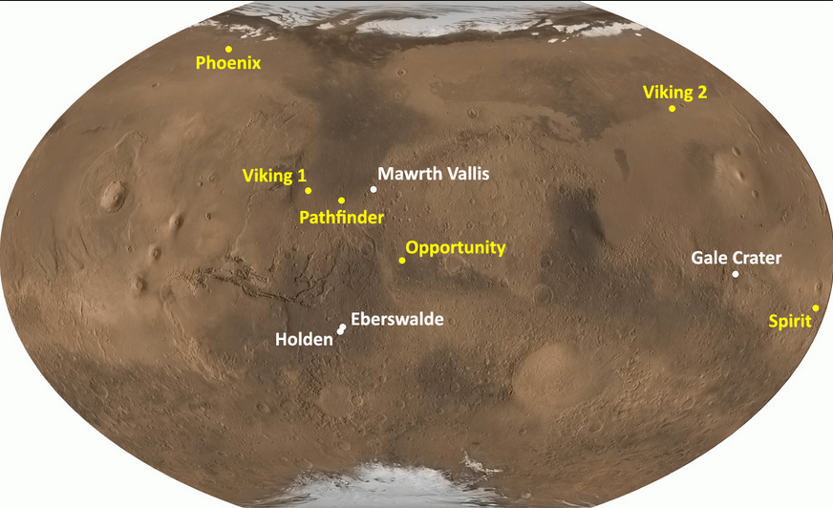

One of the missions of the Mars Curiosity Rover is to report a daily report of weather data at its location at Gale Crater in Mars’ Southern hemisphere.
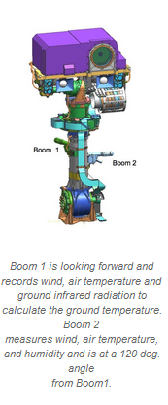

This information is recorded every sol (Martian day, approximately 24 hours, 39 minutes). But it is recorded based on number of sols after landing on Mars.
It would be more interesting to analyze this data in terms of the Martian year. One Martian year is approximately 668 sols, or 687 Earth days. Mars’ orbit is much more eccentric than Earth’s orbit, which means that it is near the Sun for less time in every year than it is distant from the Sun. Also, of course, Mars is 50% the distance from the Sun as Earth is, on average (1.5 astronomical units).
The Martian year is generally divided into seasons based on the solar longitude. The beginning of the Martian year is Ls = 0 Degrees, or the Spring Equinox (Northern Hemisphere).

The project will be to organize the Martian weather data from Curiosity by both Martian year and day-of-year, as well as by Earth date. The Earth date is not helpful in any way except to allow the user to reference Earth dates as a familiar time frame. The weather data will be harvested from data provided by Spain’s Centro de Astrobiologia (CAB). The CAB web site is down, including the API interface to this data, but it was recently harvested and placed online by Powered by Dark Sky in a csv file. The Mars calendar data is provided by The Planetary Society.

